Holoportation Is The Future!
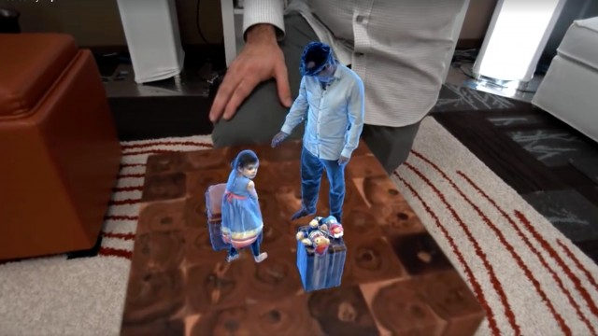
On Monday the 28th of March 2016, Microsoft unveiled its very own version of a teleporter it is calling “Holoportation”, which was designed to “teleport” 3D models of its users anywhere in the world.
The Holoportation system could radically change how we keep in touch with one another over vast distances.
The Holoportation “teleporter” uses specialized 3D cameras to capture the surrounding environment and track the user’s movements and then reconstructs it in a Virtual Reality headset in real-time. The Virtual Reality headsets allow the wearers to see and interact with remote users in 3D as if they were in the same space in real-time. To the users wearing the Virtual Reality headsets, the remote participant would appear as a hologram, giving the illusion of actually being present in the same physical space.
The Holoportation system not only works in real-time, but it can also be played back to serve as a memory.
Holoportation makes interacting with remote loved ones, friends and even business associates as natural as face-to-face communication.
The Holoportation system also allows for the miniaturization of real-time Holoports as well as the miniaturization of the playback.
Whether Microsoft runs with the idea or another company grabs the baton, Holoportation, or something similar, will happen. It just might not happen anytime soon.
Roger Minnaar
Sources:
TechNewsWorld.com
Discovery.com
Dailymail.co.uk
Zigmag.com

